A Wideband to Band-Selective Switchable Eight-Port MIMO Antenna Using a Cadmium Sulphide Photoconductive Semiconductor Switch
Adrishikhar Chowdhury, Sounak Mal and Juin Acharjee
Department of Electronics and Communication Engineering, St. Thomas’ College of Engineering and Technology, Kolkata, India
adrishikharc@gmail.com
Abstract—A switchable eight-port multiple-input multiple-output (MIMO) antenna operating in wideband and band-selective modes is demonstrated. The switching is triggered by a cadmium sulphide (CdS) photoconductive semiconductor switch actuated by a light-emitting diode. In the switched-off state the antenna operates in the wideband mode, covering 3.3–20 GHz with a 143.4 % fractional bandwidth, while in the switched-on state the extended ground plane converts the configuration to a band-selective antenna covering 9.2–13.3 GHz. Simulated results show that the wideband mode spans the upper sub-6 GHz, ultra-wideband, X and K bands, while the band-selective mode covers the X and lower Ku bands. Inter-element isolation exceeds 16 dB in the wideband mode and 12 dB in the band-selective mode. The envelope correlation coefficient remains below 0.11 and the diversity gain above 9.9 dB in both modes.
Index Terms—Cadmium sulphide (CdS), MIMO antenna, photoconductive semiconductor switch (PCSS), reconfigurable antenna, wideband antenna.
I. Introduction
Multiple-input multiple-output (MIMO) technology raises channel capacity without additional spectrum, but the gain is realised only when the radiating elements observe uncorrelated channels. Packing several elements into a small volume produces mutual coupling that raises the envelope correlation coefficient (ECC) and degrades total efficiency. A four-port superwideband MIMO antenna built from offset-fed monopole elements on a 60 × 65 mm² board is reported in [1], where orthogonal element placement provides polarisation diversity. A reconfigurable metamaterial electromagnetic band-gap MIMO array integrated with a solar panel is presented in [2], operating between 2.7 and 6.0 GHz with a peak gain of 7.3 dBi. Mutual coupling between closely spaced elements is suppressed by a composite right/left-handed isolation wall in [3]. These apertures are fixed, however, and offer no band selectivity.
An antenna operating across a wide continuous band can interfere with existing services, so designs able to switch between a wide band and a narrower selective band are correspondingly more versatile [4]. Such switching has been achieved with p-i-n diodes embedded in the feed network of capacitive coupling elements [5], with reconfigurable intelligent surfaces [6], and in pattern-reconfigurable arrays that maintain an ECC below 0.5 across their beam states [7]. All of these require a direct-current bias network. Bias lines occupy board area, radiate parasitically and perturb the ground-plane current distribution on which inter-element isolation depends, and p-i-n diodes introduce non-linearity at elevated power levels.
Photoconductive semiconductor switches (PCSS) avoid these penalties because they are actuated by light rather than by current. Silicon photoconducting switches driven by laser diodes were used in [8] to obtain a 40 % frequency shift together with a beam-null shift of about 50°. Practical actuation no longer requires laser sources: silicon microwave switches driven by ordinary light-emitting diodes were demonstrated in [9], and the linearity advantage of photoconductive switches over semiconductor diodes was characterised experimentally in [10]. Cadmium sulphide (CdS) was first used as a photoconductive switching material to control the bandwidth of a microwave filter without biasing lines [11], and this concept was applied in [12] to switch a single-port planar monopole between ultra-wideband and dual-band operation by extending the ground plane under illumination.
In this paper we extend that switching concept to a multi-port aperture. The eight-port MIMO antenna reported in [13] is modified by dividing its ground plane into four quadrants, each loaded by a rectangular stub connected to the ground through a CdS PCSS. Illuminating the CdS enhances its conductivity and extends the ground plane, so the antenna operates in a band-selective mode; turning off the illumination reduces the CdS conductivity and the antenna returns to the wideband mode. To the authors’ knowledge this is the first application of optically switched reconfiguration to an eight-port wideband MIMO aperture, where the absence of bias lines is of particular value because such conductors would otherwise degrade the inter-element isolation.

II. Antenna Structure
Fig. 1 shows the front and back views of the proposed antenna and the dimensions of each of its components. The front view, Fig. 1(a), consists of eight microstrip-line-fed half-circular radiating elements arranged in four orthogonal pairs with four-fold rotational symmetry about the centre of the board. The two feed lines of each pair are offset from one another to decorrelate their excitations. The rotational symmetry makes the scattering behaviour of all eight ports nominally identical and orients adjacent elements orthogonally, which contributes polarisation diversity without any additional decoupling structure. The overall board measures L = 55 mm × W = 55 mm. The antenna is fed by 50 Ω microstrip lines and etched on an FR-4 dielectric substrate with dielectric constant ε_{r} = 4.4, loss tangent 0.02, and height h = 1.6 mm.

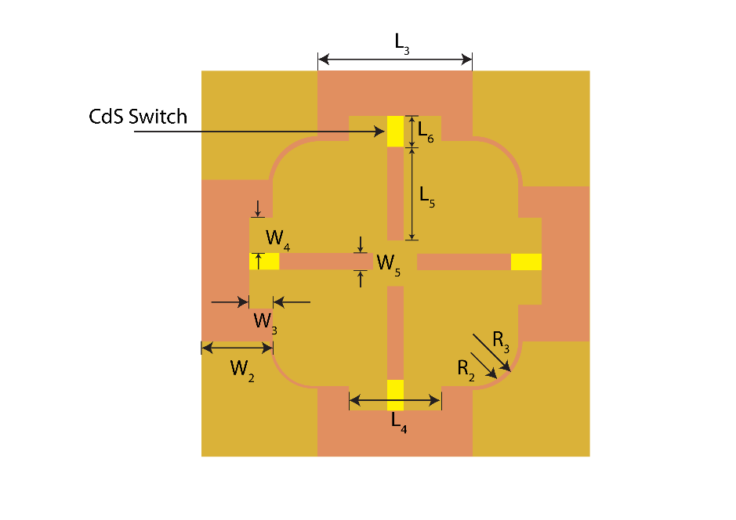
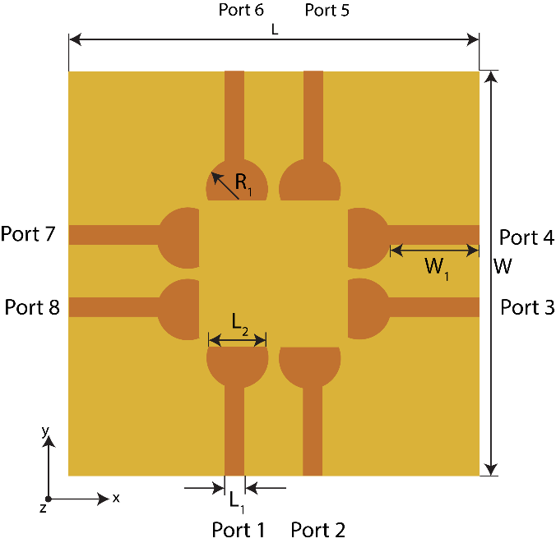
The back view, Fig. 1(b), shows a modified ground plane divided into four quadrant sections whose outer corners are rounded with radii R₁ and R₂. A narrow rectangular stub projects inward from each quadrant towards the centre of the board, separated from its quadrant by a small gap. The four stubs remain physically separate from one another, leaving an open region at the centre of the aperture, so each stub loads only the ground section from which it projects. Each stub can be connected to and disconnected from its ground quadrant by illuminating and darkening the CdS patch placed in the gap. Connecting and disconnecting the stubs switches the operating mode to band-selective and wideband mode, respectively. The complete set of dimensions is listed in Table I.
(a) (b)
Fig. 1. Geometry of the proposed eight-port switchable MIMO antenna: (a) front view; (b) back view showing the four ground quadrants, the rectangular stubs and the CdS patches.
Table I. Dimensions of the proposed antenna (mm).
Parameter | Value (mm) | Parameter | Value (mm)
L | 55 | W | 55
L₁ | 2.7 | W₁ | 12.5
L₂ | 10 | W₂ | 10
L₃ | 24 | W₃ | 5
L₄ | 10 | W₄ | 4
L₅ | 13.75 | W₅ | 2
L₆ | 5 | R₁ | 4.2
R₂ | 6.5 | R₃ | 7.2

III. Switching and Antenna Operation Concepts
Photoconductive materials, which act as conductors and insulators at the same time, are used as the switching element. Conventional switches reflect electromagnetic waves and cause coupling between the stub and the ground plane through their metallic parts even when they are turned off. Improving the contact between a conductor and a semiconductor requires high doping between the two, which was not necessary here and would add cost to the overall design [12]. A CdS photo resistor has therefore been used as a compromise between a CdS wafer and p-i-n diodes, which require biasing circuits to switch them on and off.
The CdS material was added to the simulator library with a conductivity of 82 ℧/m while operating in the dark and 10⁴ ℧/m under illumination, following the values reported in [12]. The photo resistor is controlled by a 3 V battery connected to a 20 mA light-emitting diode, so the power consumption is 60 mW. In the full-wave model the switch is represented as a finite-conductivity volume occupying the gap between each stub and its ground quadrant, and the two switching states are distinguished solely by the value assigned to this conductivity.
Illumination of the CdS patches connects each stub to its ground quadrant because the illumination enhances the CdS conductivity significantly [12]. This connection extends the antenna ground plane, and the antenna operates in a band-selective mode instead of the wideband mode. Turning off the light emitting diodes disconnects the stubs from the ground quadrants, reducing the effective ground plane size, and this modification makes the antenna operate in the wideband mode.
It is worthwhile to highlight the operation mechanism of the proposed antenna. Fig. 2 shows the surface-current distribution on the ground plane at 10 GHz in the two states. When the light is switched on, Fig. 2(a), current crosses each CdS switch and flows along the full length of every stub, with the density highest at the root of the stub immediately adjacent to the patch. Each stub therefore acts as an extension of its ground quadrant, and the enlarged ground plane suppresses the low-frequency response so that the antenna resonates only over the narrower band. When the light is switched off, Fig. 2(b), every stub appears at the minimum of the colour scale, confirming that the patches present a high impedance and that the stubs are electrically isolated. The ground plane is correspondingly smaller and the antenna operates in the wideband mode. The currents along the outer ground edges and around the feed regions are essentially unchanged between the two states, which explains why the radiation patterns retain the same general form in both modes.
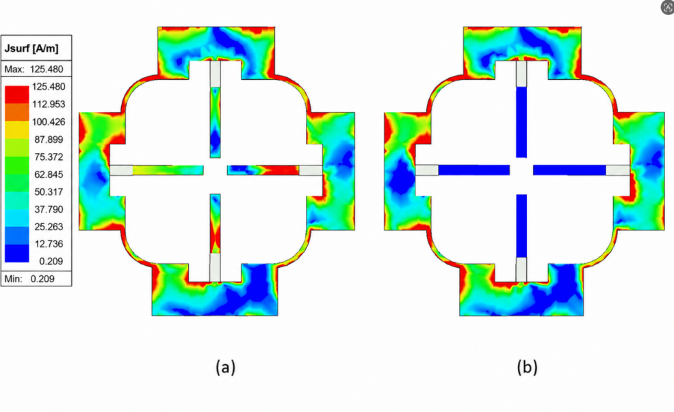
Fig. 2. Surface-current distribution on the ground plane at 10 GHz when (a) the light is on and (b) the light is off.
IV. Simulated Results and Discussion
The antenna was analysed using the finite-element solver of Ansys HFSS ____. Port ____ is excited in all simulations and the remaining seven ports are terminated in 50 Ω loads. Because of the four-fold rotational symmetry, the response of one port is representative of all eight. The reported transmission coefficient and correlation results correspond to the ____ port pair, which exhibits the strongest coupling and therefore represents the worst case.
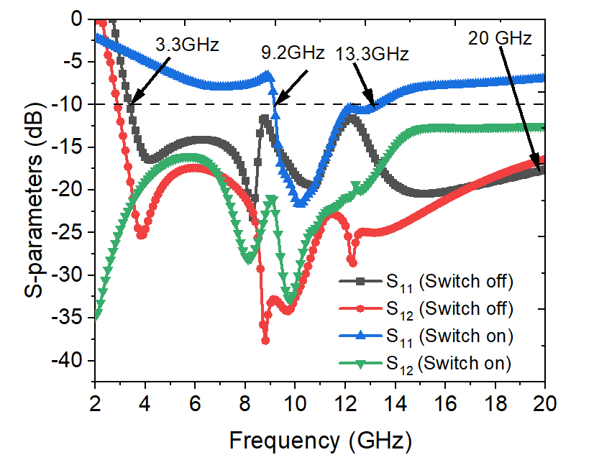
Fig. 3. Simulated reflection coefficient S₁₁ and transmission coefficient S₁₂ of the proposed antenna when the light is off and when the light is on.
A. Wideband Mode (Light is OFF)
The simulated reflection coefficient in the switched-off state is illustrated in Fig. 3. With the stubs disconnected, the reduced ground plane supports a continuous matched response: the reflection coefficient falls below −10 dB at 3.3 GHz and remains below that level up to 20 GHz. This corresponds to a fractional bandwidth of 143.4 % and a ratio bandwidth of 6.06 : 1, covering the upper sub-6 GHz range, the complete 3.1–10.6 GHz ultra-wideband allocation, the X band and the K band. Distinct resonances are visible near 6.3 GHz and 11.5 GHz, which merge to produce the continuous wideband response. The transmission coefficient between the representative port pair remains below −16 dB across the entire 2–20 GHz range, reaching a minimum of about −37.5 dB near 8.8 GHz. This isolation is obtained from the geometry alone — the orthogonal element orientation and the separation of the ground quadrants — without any dedicated decoupling structure, defected ground element or neutralisation line.
Fig. 4 shows the simulated co-polarised and cross-polarised power patterns in the two principal planes at 12 GHz. The pattern is close to omnidirectional in both planes, with a peak realised gain of approximately 2 dBi and a cross-polarisation level below −10 dB over most of the angular range, giving a discrimination better than 12 dB. The two principal-plane patterns are almost indistinguishable from one another, which is a direct consequence of the four-fold rotational symmetry of the aperture.
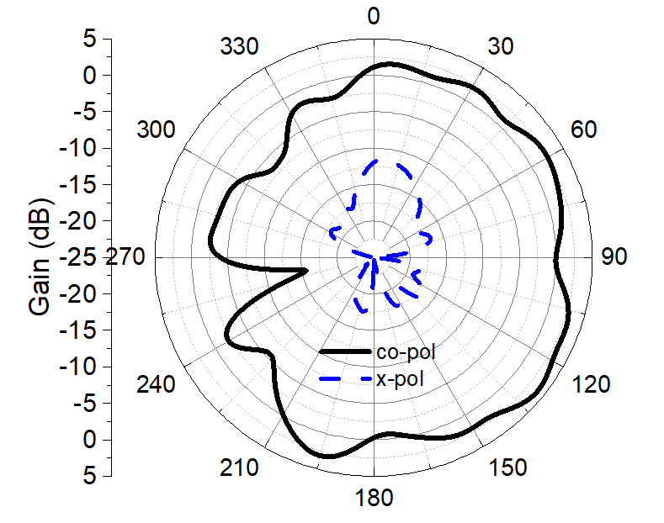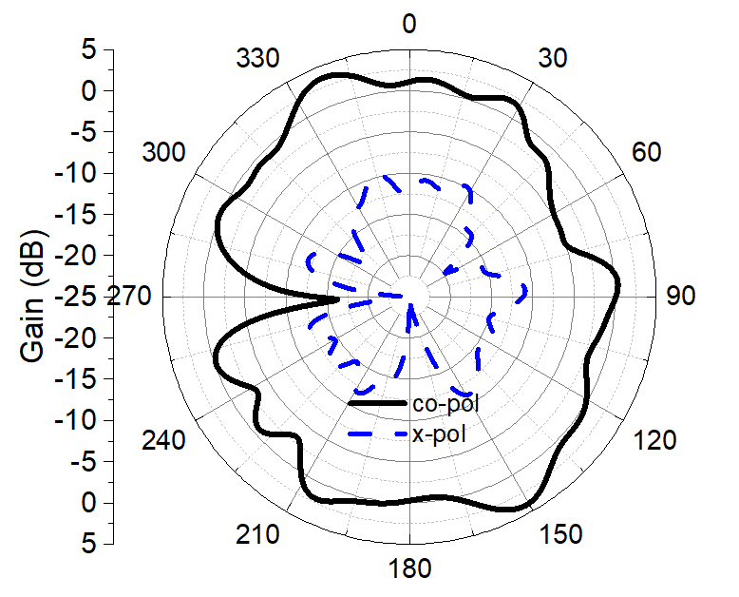
(a) (b)
Fig. 4. Simulated co-polarised and cross-polarised power patterns at 12 GHz when the light is off: (a) φ = 0° plane; (b) φ = 90° plane.
B. Band-Selective Mode (Light is ON)
When light is applied to the CdS patches the ground plane is extended and the antenna is no longer wideband, but operates as a band-selective antenna covering 9.2–13.3 GHz, a fractional bandwidth of 36.4 % centred on 11.25 GHz. This band supports X-band satellite communication and lower Ku-band links. Fig. 3 illustrates the reflection coefficient in this mode: the response stays above −10 dB throughout the lower part of the spectrum and above 13.3 GHz, so the out-of-band interference that the wideband mode admits is rejected. The transmission coefficient remains below −12 dB across 2–20 GHz and below −20 dB throughout the 9.2–13.3 GHz operating band.
The simulated power patterns at 10 GHz are shown in Fig. 5. The antenna retains a near-omnidirectional pattern in both principal planes with a peak realised gain of approximately 2.5 dBi, and the cross-polarisation level remains below −10 dB. The preservation of the pattern shape between the two modes is consistent with the current distributions of Fig. 2, which showed that switching alters the current on the stubs but leaves the currents on the radiating elements largely intact.
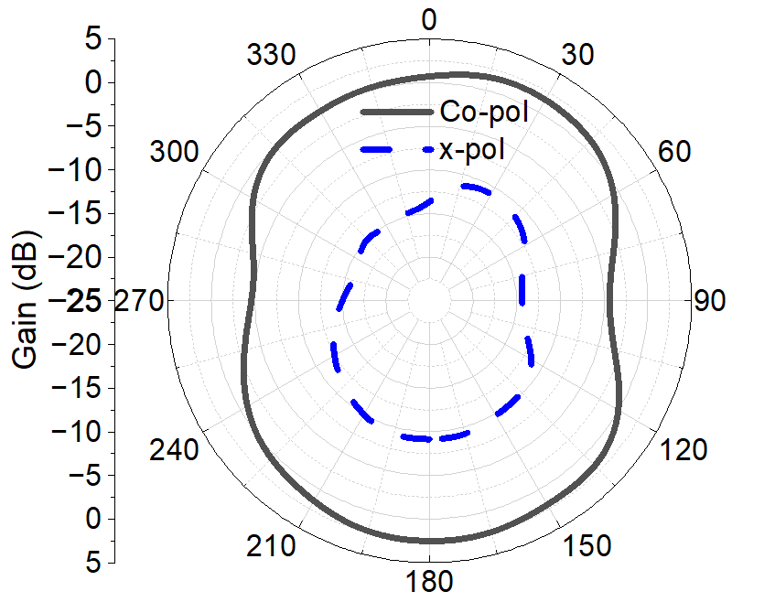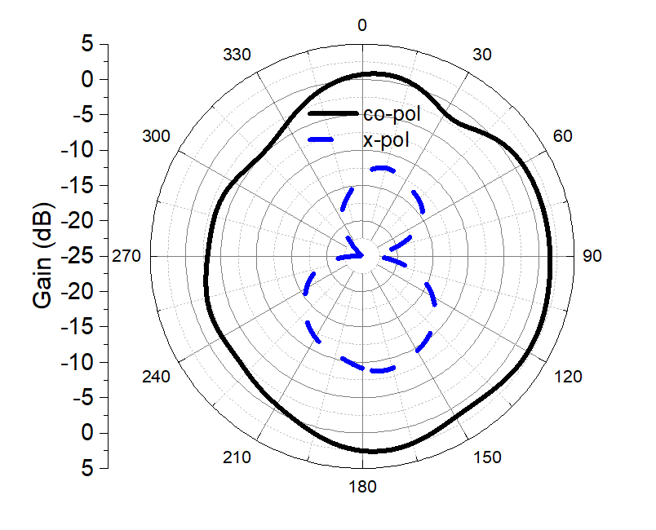
(a) (b)
Fig. 5. Simulated co-polarised and cross-polarised power patterns at 10 GHz when the light is on: (a) φ = 0° plane; (b) φ = 90° plane.
C. MIMO Diversity Performance
The suitability of the aperture for MIMO operation was assessed using the envelope correlation coefficient and the diversity gain. The ECC between ports i and j was computed from the scattering parameters as
ρₑ,ᵢⱼ = |S*ᵢᵢ Sᵢⱼ + S*ⱼᵢ Sⱼⱼ|² / [(1 − |Sᵢᵢ|² − |Sⱼᵢ|²)(1 − |Sⱼⱼ|² − |Sᵢⱼ|²)] (1)
and the diversity gain follows as
DG = 10 √(1 − |ρₑ|²) (2)
Equation (1) is strictly valid for a lossless two-port system; for the present eight-port aperture on a lossy substrate it is used as a first-order estimate, which is standard practice. Figs. 6 and 7 show the ECC and the diversity gain in both modes. The ECC remains below the 0.5 threshold conventionally taken as the limit for acceptable diversity performance throughout both operating bands. In the wideband mode the highest value is 0.42, occurring at the 3.3 GHz lower band edge where the match is marginal; above 3.4 GHz the coefficient falls below 0.1 and remains there up to 20 GHz. In the band-selective mode the ECC stays below 0.11 across the whole 9.2–13.3 GHz band, rising to that value only at the 13.3 GHz upper edge. The corresponding diversity gain exceeds 9.0 dB in the wideband mode and 9.9 dB in the band-selective mode, the latter being close to the theoretical maximum of 10 dB. The excursions visible outside the respective matched bands, including the peak near 16 GHz in the light-on curve, are an artefact of the scattering-parameter formulation: where the antenna is unmatched the denominator of (1) approaches zero and the computed correlation loses meaning. Only the matched bands are therefore interpreted.
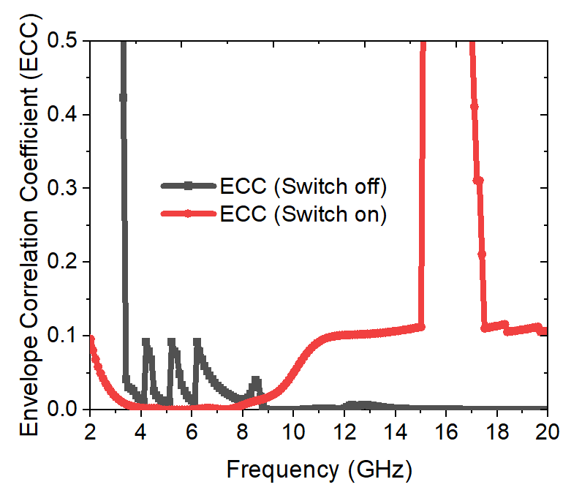
Fig. 6. Simulated envelope correlation coefficient when the light is off and when the light is on.
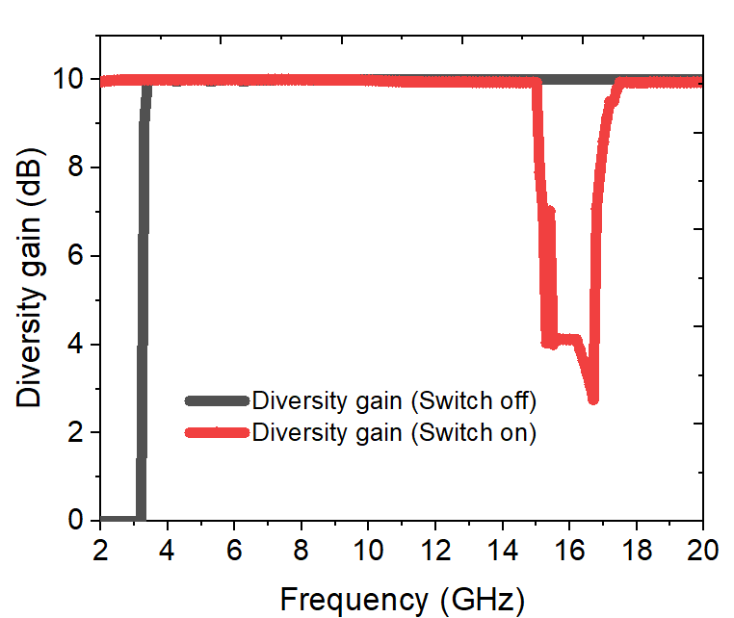
Fig. 7. Simulated diversity gain when the light is off and when the light is on.
▶ OPTIONAL, cosmetic only. Two export artefacts remain in Fig. 6: the excursion near 16 GHz in the light-on curve (outside its 9.2–13.3 GHz band) and three spikes near 4.3, 5.3 and 6.3 GHz in the light-off curve (in-band but reaching only 0.09). Neither affects the ECC < 0.5 claim, which holds in both bands. Re-exporting the sweep from HFSS would remove both and tidy the figure.
D. Comparison with Related Work
Table II compares the proposed antenna with related reported designs. The proposed design offers the largest number of ports among the compared works while retaining a continuous wideband response in the switched-off state, and it is the only multi-port design in the comparison that provides band reconfiguration without a direct-current bias network.
Table II. Comparison with related reported designs.
Ref. | Ports | Size (mm²) | Operating band (GHz) | Isolation (dB) | ECC | Switching mechanism | Peak gain (dBi)
[1] | 4 | 60 × 65 | SWB | — | — | None (fixed) | —
[2] | 4 | — | 2.7 – 6.0 | — | — | None (fixed) | 7.3
[3] | — | — | — | — | — | None (CRLH wall) | —
[5] | — | — | — | — | — | p-i-n diode | —
[7] | — | — | — | — | < 0.5 | Pattern reconfig. | —
[8] | 1 | — | 40 % freq. shift | — | — | Si PCSS (laser) | —
[12] | 1 | 25 × 40 | 3.1 – 10.6 (OFF) 3.5 / 7.5 (ON) | — | — | CdS PCSS (LED) | ≈ 4
This work | 8 | 55 × 55 | 3.3 – 20 (OFF) 9.2 – 13.3 (ON) | > 16 (OFF) > 12 (ON) | < 0.11 | CdS PCSS (LED) | ≈ 2.5

▶ FILL THE DASHES in Table II from the cited papers, and replace “L × W” in the last row with your own board dimensions.
V. Conclusion
A switchable eight-port MIMO antenna has been designed and analysed to demonstrate operation in two different modes. The switching between the two modes is achieved by illuminating CdS photoconductive semiconductor switches placed between four rectangular stubs and the quadrants of the antenna ground plane. Illuminating the switches extends the ground plane and converts the antenna from the wideband mode to the band-selective mode. Simulated results show that in the wideband mode the antenna covers 3.3–20 GHz, spanning the sub-6 GHz, ultra-wideband, X and K bands, while in the band-selective mode it covers 9.2–13.3 GHz for X-band satellite and lower Ku-band communication. Inter-element isolation exceeds 16 dB and 12 dB in the two modes respectively, obtained from the aperture geometry alone, and the envelope correlation coefficient remains below 0.11 with a diversity gain above 9.9 dB. Because the switching is optical, no biasing circuit is needed to control the operation, which preserves the ground-plane current distribution on which the isolation depends. Fabrication of a prototype and experimental verification of both modes form the next stage of this work.
Acknowledgment
▶ Add if required by the conference, or delete this heading.
References
[1] A. Author, B. Author, and C. Author, “Title of the quad-port superwideband MIMO antenna paper,” Journal Name, vol. __, no. __, Art. 8882866, 2023.
[2] A. Author et al., “Reconfigurable MTM-EMBG MIMO antenna array with solar panel integration,” Sci. Rep., vol. 16, Art. 22140, 2026.
[3] A. Author et al., “Composite right/left-handed isolation wall for mutual coupling reduction in MIMO antennas,” Journal Name, vol. __, pp. __–__, ____.
[4] J. Costantine, Y. Tawk, S. E. Barbin, and C. G. Christodoulou, “Reconfigurable antennas: Design and applications,” Proc. IEEE, vol. 103, no. 3, pp. __–__, Mar. 2015.
[5] A. Author et al., “Pattern-reconfigurable capacitive coupling element antenna with a p-i-n diode feed network,” Journal Name, vol. __, pp. __–__, ____.
[6] A. Author et al., “Reconfigurable intelligent surface based antenna design,” Journal Name, vol. __, pp. __–__, ____.
[7] A. Author et al., “Pattern-reconfigurable MIMO antenna with low envelope correlation,” Journal Name, vol. __, pp. __–__, ____.
[8] C. J. Panagamuwa, A. Chauraya, and J. C. Vardaxoglou, “Frequency and beam reconfigurable antenna using photoconducting switches,” IEEE Trans. Antennas Propag., vol. 54, no. 2, pp. 449–454, Feb. 2006.
[9] D. Zhao, Y. Han, Q. Zhang, and B.-Z. Wang, “Experimental study of silicon-based microwave switches optically driven by LEDs,” Microw. Opt. Technol. Lett., vol. 57, no. 12, pp. 2768–2774, 2015.
[10] E. K. Kowalczuk, C. J. Panagamuwa, R. D. Seager, and J. C. Vardaxoglou, “Characterising the linearity of an optically controlled photoconductive microwave switch,” in Proc. Loughborough Antennas Propag. Conf. (LAPC), 2010, pp. 597–600.
[11] J. Wu and I. Shih, “A novel switchable microwave filter constructed with inter-coupled split-ring resonators and photosensitive cadmium sulfide,” in Proc. Int. Symp. Signals, Syst. Electron., 2007, pp. 435–438.
[12] F. M. Alnahwi, K. M. Abdulhasan, and N. E. Islam, “An ultrawideband to dual-band switchable antenna design for wireless communication applications,” IEEE Antennas Wireless Propag. Lett., vol. 14, pp. 1685–1688, 2015.
[13] [Your previously presented paper on the base eight-port MIMO geometry — insert full details]
▶ YOU MUST COMPLETE: references [1], [3], [5], [6], [7] and [13]. Also verify the page range of [4]. References [2], [8], [9], [10], [11] and [12] are fully verified and need no change.

